### 

### Hands-On for Querying with filters

### 

**1. Create a Database named "Stocks"**

**O/P:**



**2. Create an empty collection named "inventory"**

**O/P:**



**3. Insert below records in the inventory collection all together.**

**O/P:**

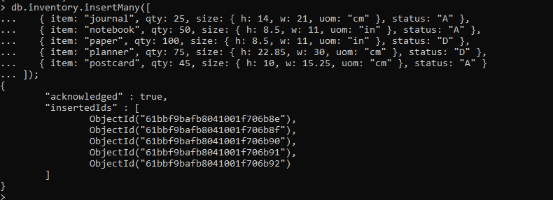

**4. Select all documents from inventory collection**

**O/P:**

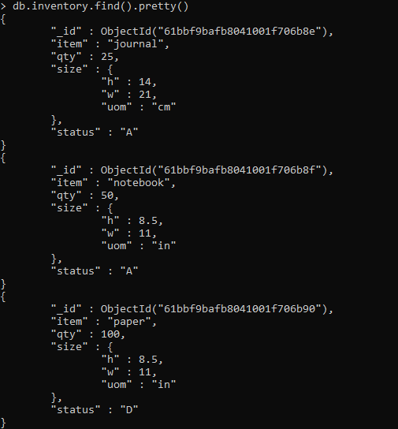

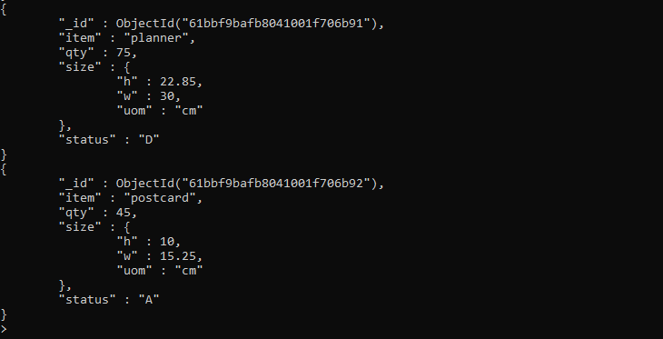

**5. selects from the inventory collection all documents where the status equals "D"**

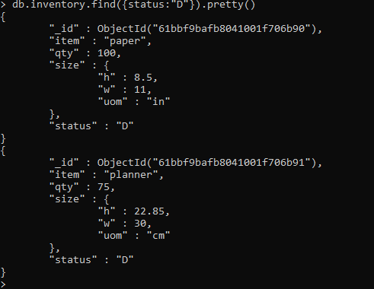

**6. Retrieves all documents from the inventory collection where status equals either "A" or "D".**

**O/P:**

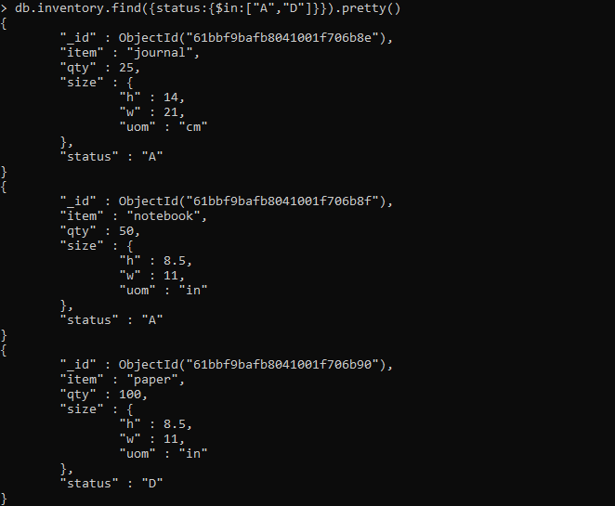

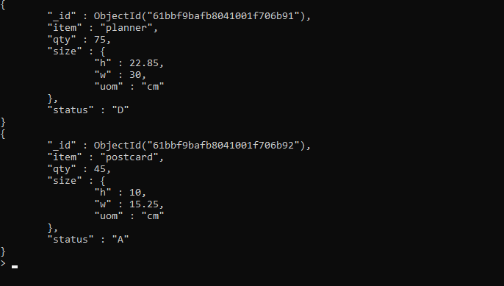

**7. Retrieve documents in the inventory collection where the status equals "A" and qty is less than (**[**$lt**](https://docs.mongodb.com/manual/reference/operator/query/lt/#op._S_lt)**) 30**

**O/P:**

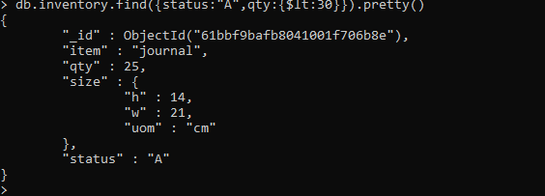

**8. Retrieve all documents in the collection where the status equals "A" or qty is less than (**[**$lt**](https://docs.mongodb.com/manual/reference/operator/query/lt/#op._S_lt)**) 30**

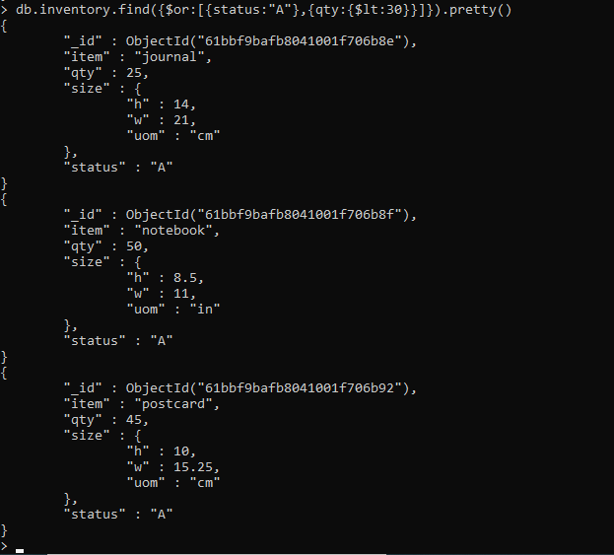

**9. Update qty to 25 where item is notebook**



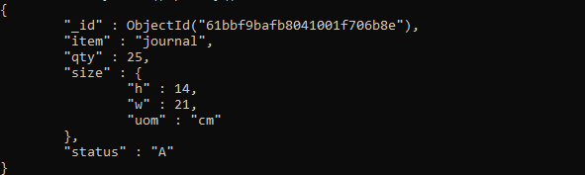

**10. Update all status to 'B' where status is 'D'**

**O/P:**



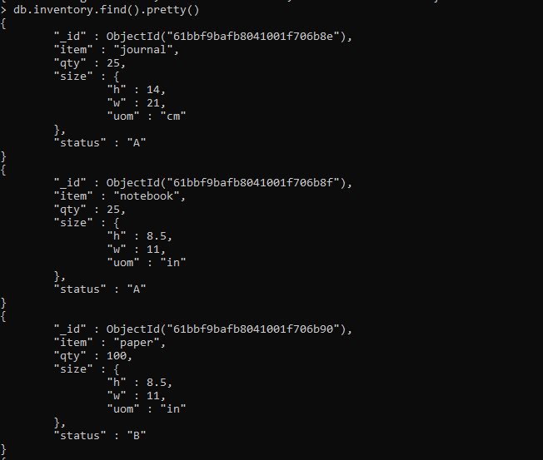

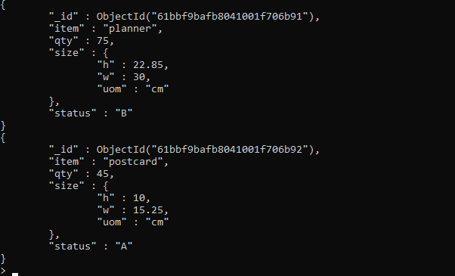

**11. Write a query to demonstrate usage of upsert.**

**O/P:**

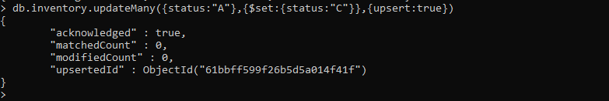

**12. Delete the document where qty is 100**

**O/P:**



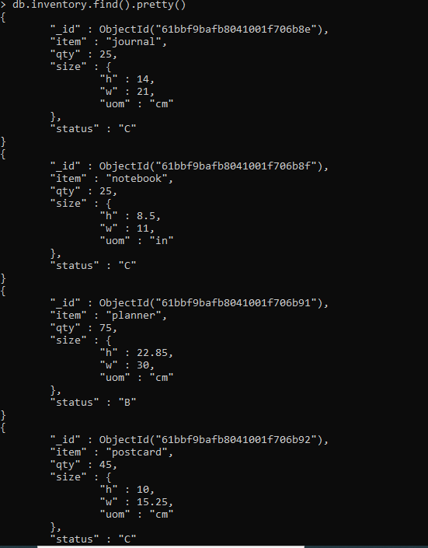

**13. Delete all the documents from inventory collection.**

**O/P:**

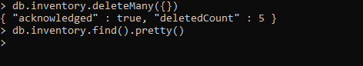

**14. Rename the collection.**

**O/P:**





**15. Delete the database.**

**O/P:**

